**Lab Report : 01**

**Title: Computer Graphics**

*Course title: Database Systems Laboratory*

*Course code: CSE-256*

*3rd Year 1st Semester Examination 2022*

**Date of Submission**: 12.11.2022



**Submitted to-**

Dr. Md. Shorif Uddin

***Professor***

Dr. Morium Akter

***Assistant Professor***

*Department of Computer Science and Engineering*

*Jahangirnagar University*

*Savar, Dhaka-1342*

| **Sl** | Class Roll | Exam Roll | Name |
| --- | --- | --- | --- |
| 01 | 383 | 202195 | Sakul Mia |

**1 Code : Scan Converting of a point :**

#include <iostream>

int main() {

int x = 5;

int y = 3;

for (int i = 1; i <= y; ++i) {

std::cout << std::endl;

}

for (int i = 1; i <= x; ++i) {

std::cout << " ";

}

std::cout << "*" << std::endl;

return 0;

}

Output :

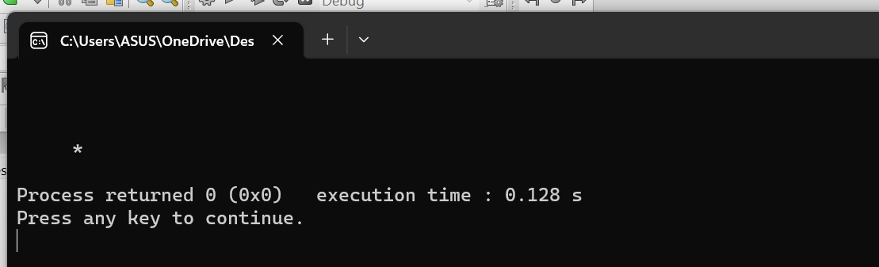

2 Code: Scan Converting of line using DDA

#include <iostream>

#include <graphics.h>

using namespace std;

void drawLineDDA(int x1, int y1, int x2, int y2) {

int dx = x2 - x1;

int dy = y2 - y1;

int steps = abs(dx) > abs(dy) ? abs(dx) : abs(dy);

float xIncrement = static_cast<float>(dx) / steps;

float yIncrement = static_cast<float>(dy) / steps;

float x = static_cast<float>(x1);

float y = static_cast<float>(y1);

for (int i = 0; i <= steps; ++i) {

putpixel(static_cast<int>(x), static_cast<int>(y), WHITE);

x += xIncrement;

y += yIncrement;

}

}

int main() {

int x1 = 100, y1 = 100;

int x2 = 400, y2 = 300;

cout<<"Enter X1 value and Y1 vale : ";

cin>>x1>>y1;

cout<<"Enter X2 value Y2 value : ";

cin>>x2>>y2;

int gd = DETECT, gm;

initgraph(&gd, &gm, "");

drawLineDDA(x1, y1, x2, y2);

delay(200000);

closegraph();

return 0;

}

Output :

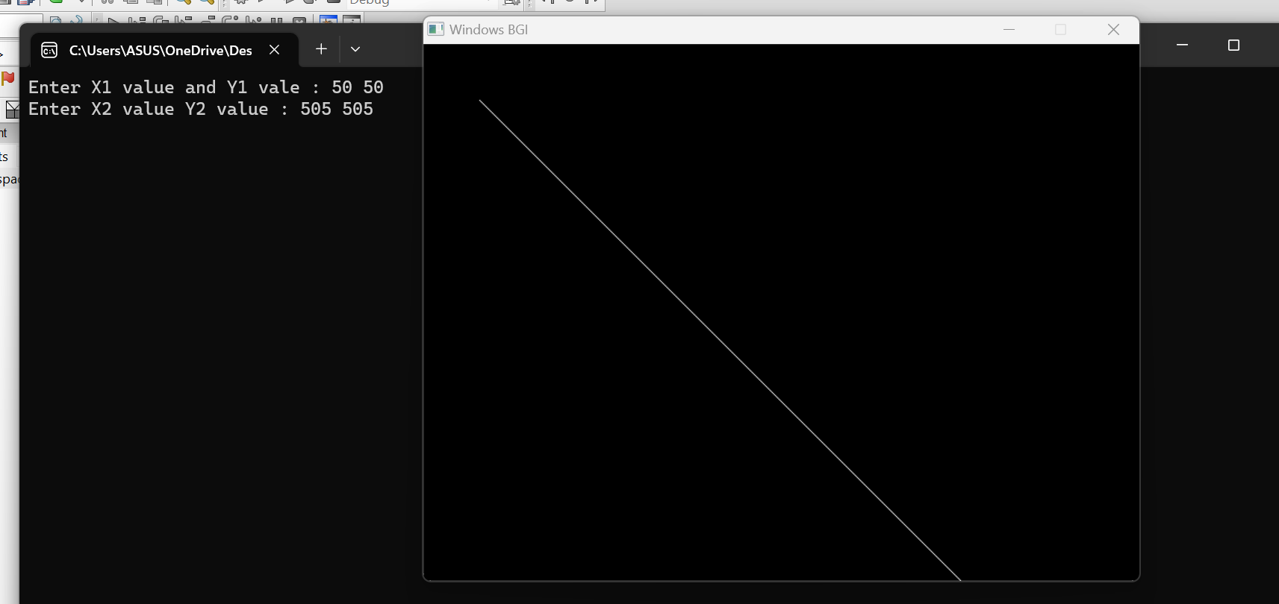

3 Code : Scan converting of line using Bresenham

#include <iostream>

#include <graphics.h>

using namespace std;

void drawLineBresenham(int x1, int y1, int x2, int y2) {

int dx = abs(x2 - x1);

int dy = abs(y2 - y1);

int sx = (x1 < x2) ? 1 : -1;

int sy = (y1 < y2) ? 1 : -1;

int err = dx - dy;

while (true) {

putpixel(x1, y1, WHITE);

if (x1 == x2 && y1 == y2)

break;

int err2 = 2 * err;

if (err2 > -dy) {

err -= dy;

x1 += sx;

}

if (err2 < dx) {

err += dx;

y1 += sy;

}

}

}

int main() {

int x1 = 100, y1 = 100;

int x2 = 400, y2 = 300;

cout<<"Enter X1 value and Y1 vale : ";

cin>>x1>>y1;

cout<<"Enter X2 value Y2 value : ";

cin>>x2>>y2;

int gd = DETECT, gm;

initgraph(&gd, &gm, "");

drawLineBresenham(x1, y1, x2, y2);

delay(200000);

closegraph();

return 0;

}

Output :

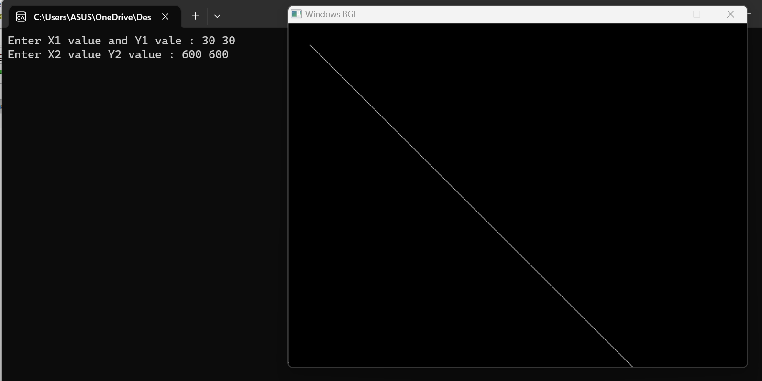

4 Code : Scan converting of line using circle

#include <iostream>

#include <graphics.h>

using namespace std;

int main() {

int x,y,redius;

cout<<"Enter X1 value and Y1 vale : ";

cin>>x>>y;

cout<<"Enter value of R : ";

cin>>redius;

int gd = DETECT, gm;

initgraph(&gd, &gm, "");

circle(x, y, redius);

delay(200000);

closegraph();

return 0;

}

Output :

